Development of a Simple R Package (aLBI) for the Estimation of Stock Status from the Length Frequency Data

Ataher Aliª, Mitu Ranjan Sarker^{b}, Mohammed Shahidul Alamª*

ªDepartment of Fisheries, University of Chittagong, Chattogram- 4331, Bangladesh; ataher.cu.ms@gmail.com; alamms@cu.ac.bd
^{b}Institute of Marine Sciences, University of Chittagong, Chattogram- 4331, Bangladesh; mitusarkerims@cu.ac.bd

*Correspondence author e-mail: alamms@cu.ac.bd

ABSTRACT
Stock assessment is a difficult task for sustainable fisheries management especially when population and fisheries data are limited. This study aims to develop a simple and well-tested R package (aLBI) to facilitate the fish stock status assessment by providing robust functions for estimating length-based indicators (LBIs) and the stock heath by utilizing the length frequency data. The primary objective is to streamline the calculation of different size mates and visualization of the estimated metrices for more accurate and efficient understanding. The package includes two main functions for calculating key LBIs such as maximum length (L_{max}), asymptotic length (L∞), length at sexual maturity (L_{mat}), optimum length (L_{opt}), L_{opt}±10% (L_{opt_p}10, Lopt_m10) with confidence intervals, and percentages of fish at maturity (P_{mat}), optimum length (P_{opt}), and mega spawner size (P_{mega}). This study also evaluated the performance of accuracy of this package by validating with real world length frequency data. The findings demonstrate its utility in producing reliable stock assessments, with mean estimates for L_{max}, L∞, L_{mat}, and L_{opt} at 72.43 cm, 76.24 cm, 40.90 cm, and 43.72 cm, respectively, and confidence intervals supporting their reliability. Percentages of fish at maturity, optimum length, and mega spawner size are 12.319%, 14.189%, and 6.967%, against targets of 100% and 20%. Additionally, the stock status indicators show probabilities of 67% for both TSB40 and LSB25. By integrating advanced statistical methods and user-friendly interfaces, aLBI enables effective monitoring of fish populations and informed decision-making. Tested on various datasets, the package consistently performs accurately. Its ease of use and robust inferences make it an essential resource for researchers and managers. Future recommendations include expanding functionality to cover more species and integrating additional biological parameters for enhanced stock assessments. Continued collaboration with the fisheries science community will ensure aLBI remains a cutting-edge tool for sustainable fisheries practices.

Key words: R package development, stock assessment, aLBI, length-based indicators (LBIs), target biomass, limit biomass, Kaptai Lake.

INTRODUCTION
Fish stock assessment is a crucial element in the management and conservation of fishery resources, aiming to provide reliable estimates of fish population dynamics, exploitation levels, and sustainable yield. Effective fish stock assessment ensures that fishery management decisions are based on sound scientific evidence, promoting the long-term sustainability of marine ecosystems and the fishing industry (Hilborn & Walters, 1992; FAO, 2020). It allows for the determination of fishing quotas, the identification of overfished stocks, and the implementation of conservation measures. Without reliable stock assessments, fisheries management cannot effectively balance exploitation with conservation, leading to the depletion of fish stocks and the collapse of fisheries (Pilling et al., 2008). Thus, knowledge about the population status that underpins small-scale fisheries is critical for effective management. However, the application of traditional stock assessment methods to these populations is often hampered by numerous uncertainties, such as challenges in data collection due to the lack of monitoring and control programs (Hilborn and Walters, 1992; Scott et al., 2016). This has led to the creation and use of stock assessment methods designed for data-limited fisheries. These methods include those that analyze landings data and life history parameters (e.g., Martell and Froese, 2013; Thorson and Cope, 2015; Zhou et al., 2017; Free et al., 2017; Canales et al., 2018), as well as the utilization of catch length-frequency data in cohort analysis models (e.g., Hordyk et al., 2014; Froese et al., 2018; Prince et al., 2015; Rudd and Thorson, 2018; Ault et al., 2019). Collecting length-frequency data is often more straightforward and cost-effective than gathering landings data, and the resultant data tend to be more reliable (Chong et al., 2020; Pilling et al., 2008; Hordyk et al., 2015; Mildenberger et al., 2017; Froese et al., 2018). Nonetheless, many of these data-poor assessment methods, which rely on length-frequency data, often presume time-invariant fishing mortality and recruitment, a presumption that is both unrealistic (Thorson et al., 2014) and problematic. For instance, with limited length-frequency data, distinguishing whether a higher proportion of juveniles in the catch is due to successful recruitment or overexploitation of larger fish becomes highly challenging (Rudd and Thorson, 2018).
Conversely, in cases of limited data access, length-based stock evaluation methods provide a good and typically more practical option (Pauly & Morgan, 1987). Using length frequency data, these techniques estimate significant population parameters like patterns of recruitment, growth rates, mortality rates due from natural causes and fishing, and so on (Sparre & Venema, 1998). One consistent approach to find length frequency information is to look at fish landings or market samples. These techniques are economically priced and readily accessible for many fishing businesses especially in developing nations (Gayanilo & Sparre et al., 2005). For fisheries management especially in areas with low financial and technological resources, the simplicity and cost-effectiveness of the length frequency data collecting method appeal (Hoggarth et al., 2006).
The Sperata aor (Hamilton, 1822), commonly known as the long-whiskered catfish, is an important species within the Bagridae family, widely distributed across freshwater systems in South Asia, including the river basins of the Ganges, Brahmaputra, and Indus. In Bangladesh, this species is notably prevalent in Kaptai Lake, an artificial reservoir created by damming the Karnaphuli River in the Chittagong Hill Tracts. Kaptai Lake is vital for supporting local fisheries, including Sperata aor, which plays a crucial role in the livelihoods of numerous fishing communities in the region (Hossain et al., 2012). The lake is a significant source of fish for local markets, contributing to both food security and the local economy (Shalehin et al., 2022). However, increased fishing pressure, along with environmental changes and habitat degradation, has raised concerns about the sustainability of Sperata aor populations in Kaptai Lake and other freshwater ecosystems across Bangladesh. Factors such as overfishing, pollution, and habitat alterations due to the construction of the Kaptai Dam have caused fluctuations in fish populations (Khatun et al., 2023). This situation highlights the need for effective management and conservation strategies to ensure the long-term viability of this vital fishery. Given the cultural and economic significance of Sperata aor in local diets and traditional practices, sustainable exploitation and conservation efforts are crucial for maintaining ecological balance in Kaptai Lake and preserving the biodiversity that supports local communities (Rana et al., 2024).
Although numerous tools and approaches are available for assessing stock based on length, many existing R packages have limitations in terms of their adaptability, applicability, and possibility to add complex statistical models. Software applications such as "TropFishR" and "fishmethods," for example, offer helpful features but might not completely meet the multiple needs of fisheries scientists and managers in different circumstances (Mildenberger et al., 2017; Nelson, 2017). The difficulties highlight the need of developing a basic R package with uniform tools for managers and fisheries researchers that can close current gaps. These constraints motivate programmers to create a fresh R tool for length-based stock research. Modern statistical methods including Bayesian approaches and machine learning algorithms, which can considerably increase the accuracy and dependability of stock assessments (Punt et al., 2020) might not be able to be included into current tools or have the flexibility needed to fit different fisheries environment. Bayesian methods, for instance, allow one to add previous data and can more effectively control uncertainty, therefore providing a more comprehensive picture of market movements (Gelman & Shalizi, 2013). Furthermore, machine learning techniques help one to identify trends and anomalies in length frequency data, thereby checking the veracity of death and growth projections (Olden et al., 2008).
Furthermore, accessibility and user-friendliness are absolutely vital to guarantee that fisheries managers might optimize these tools without depending on major statistical programming expertise (Wickham, 2015). A well-designed R package with basic functions, extensive documentation, and interactive visualization components assisting to adopt length-based evaluation methodologies can benefit many diverse fisheries situations. This work aims primarily to create a scientifically valid, user-friendly, robust R software for length-based fish stock assessment. Thus, this study intends to design and develop an R package that integrates advanced statistical models and visualization tools for fisheries data analysis. In addition, it aims to provide comprehensive documentation and user support for the package and validate the R package by using real-world length frequency data of Sperata aor.

METHODOLOGY

Study area
This study focuses on the collection of length frequency data of Sperata aor from Kaptai Lake, located in the Chattogram district of Bangladesh (latitude: 22°30'00" N and longitude: 92°13'00" E). Kaptai Lake, the largest man-made freshwater lake in the country, is a vital resource for local fisheries and communities. Situated in the Rangamati district, the lake interconnects several upazilas, including Rangamati Sadar, Langadu, Nannerchar, Jurachari, Kaptai, and Belaichari. It is fed by the Karnaphuli, Chengi, Mayani, Kassalong, and Rinkhyong rivers. The lake lies in the southeast part of Bangladesh, within the coordinates of latitude 22°22' to 23°18'N and longitude 92°00' to 92°26'E (Figure 1).
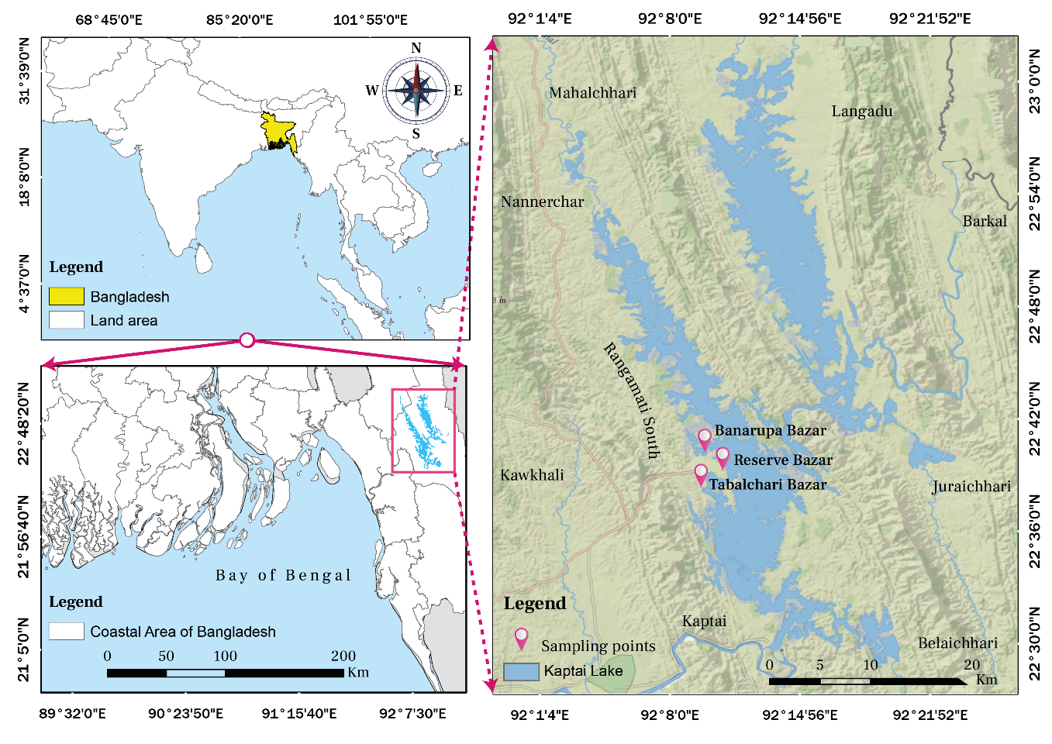
Figure 1: Map showing the sampling points of the study

Collection of length frequency data
The collection of length frequency data is an essential aspect of fisheries management, providing critical insights into the population dynamics and exploitation levels of various fish species. In this study, monthly sampling was carried out at three landing center (Figure 1) for eight months from August 2022 to March 2023 (Figure 2) and measured a total of 1177 individuals of Sperata aor (both sex). The data collection encompasses various gear types, including gillnets, cast nets, and traps, reflecting the diverse fishing practices in the region. The boats used range from traditional non-motorized wooden boats to small motorized vessels, indicating the adaptability of fishers to different fishing conditions. Fishing activities in Kaptai Lake are highly seasonal, with peak periods aligning with monsoon and post-monsoon seasons, which significantly influence fish behavior and availability. This study aims to provide a comprehensive overview of the length frequency data collection process for Sperata aor, contributing to sustainable fisheries management and conservation efforts in Kaptai Lake.
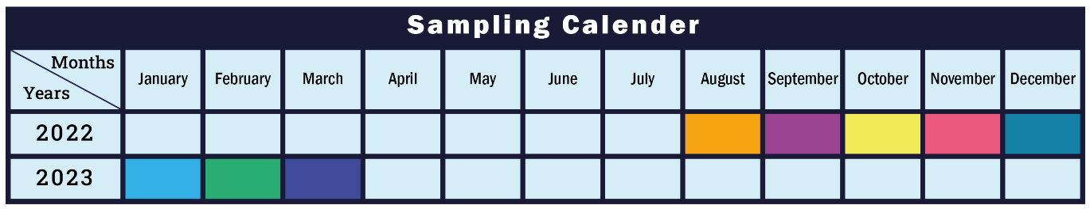
Figure 2: Sampling calendar of the study

Package development
Package development in R empowers researchers and analysts to create reusable, efficient, and shareable code tailored to specific analytical needs. By packaging functions, data, and documentation, users can streamline workflows and ensure reproducibility. This approach enhances collaboration and allows for easy distribution of tools within the R community. A simple non-overlapping unique name aLBI was given for the package which defines it best. This makes it easy for potential users to find your package and associated resources. Also check if a name is already used on CRAN by loading http://cran.r project.org/web/packages/[aLBI]. The aLBI package was created by following steps shown in Figure 3. The package was created with a D/R/MyRpackage directory, man/directory, basic DESCRIPTION, NAMESPACE file etc. shown in Figure 3. The R project will also include an RStudio project file aLBI.Rproj, which makes aLBI package easy to use with RStudio.

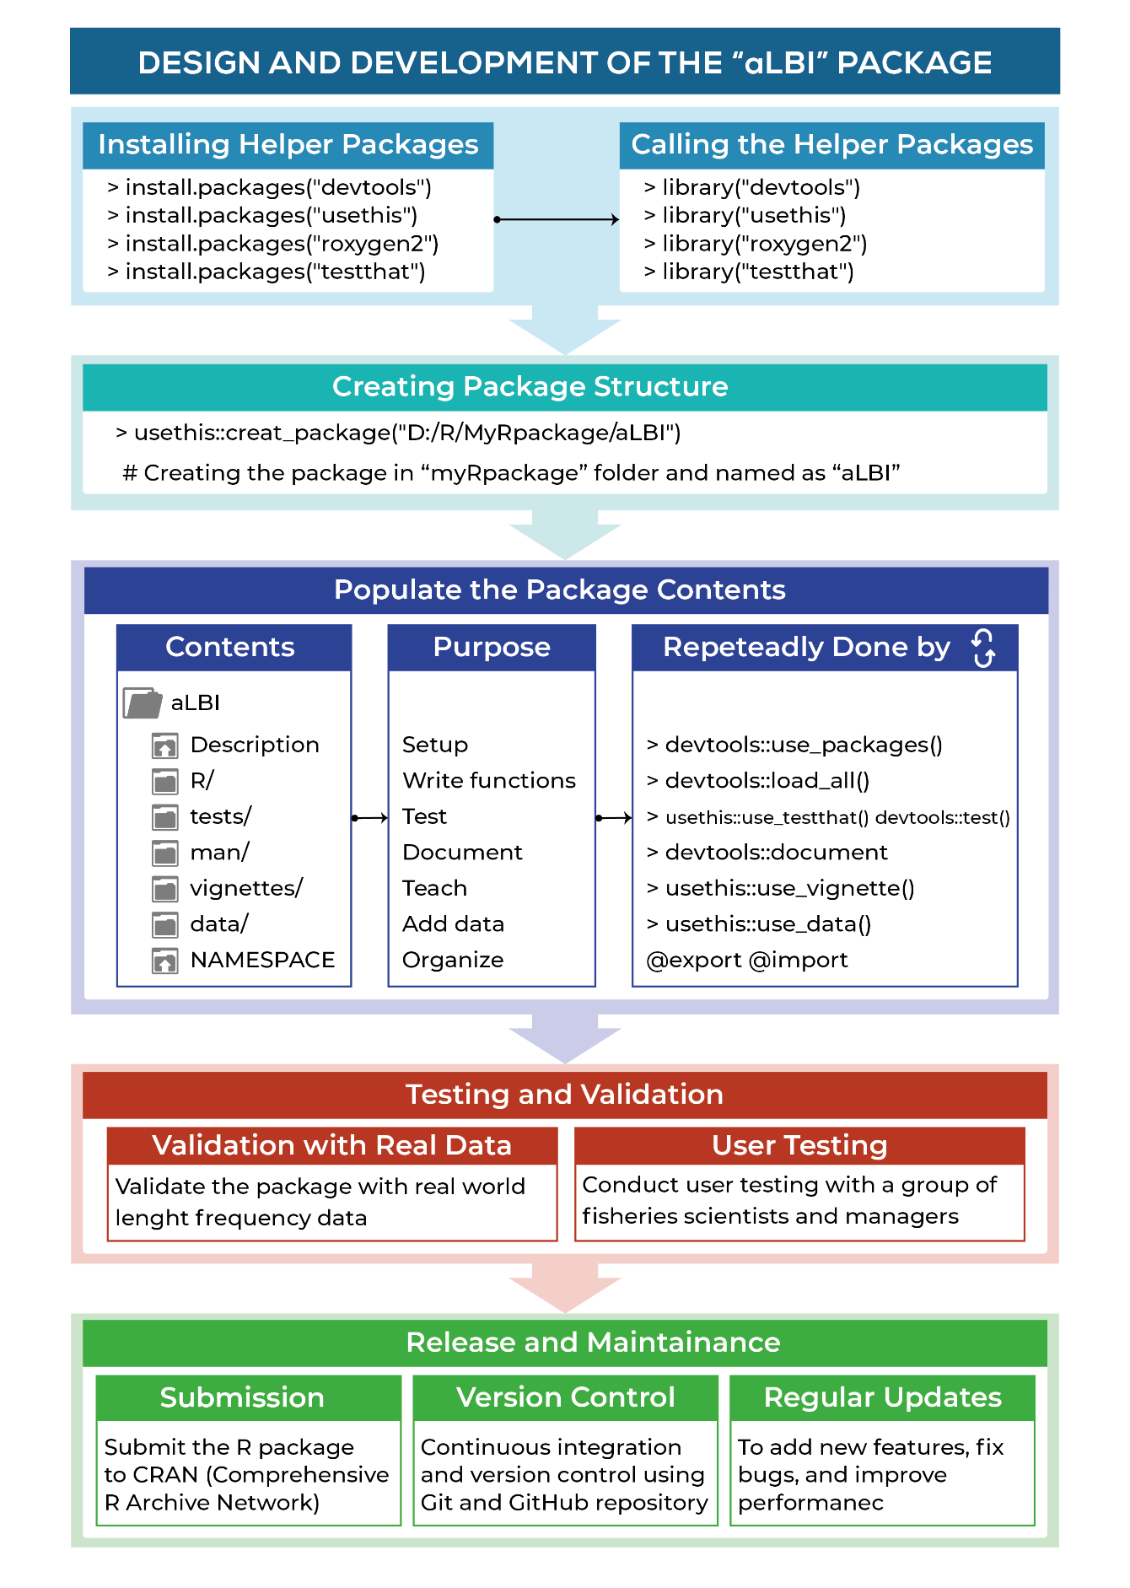
Figure 3: Design and development process of the aLBI package

Main functions
Version 0.1.5 of aLBI package is written in R (version 4.2.1), organized using roxygen2 (Wickham et al., 2024) and depends on no such packages. This is designed to be used with a data frame in R environment. The development and planning process of aLBI package involves a repeated process from uncountable times (Figure 4). The first practical advantage to using a package is that it’s easy to reload all the code and functions. All the open files were saved by running devtools::load_all() and also whenever it needs to change or edit any code or functions, this workflow will reload all the edited R files (Figure 4).
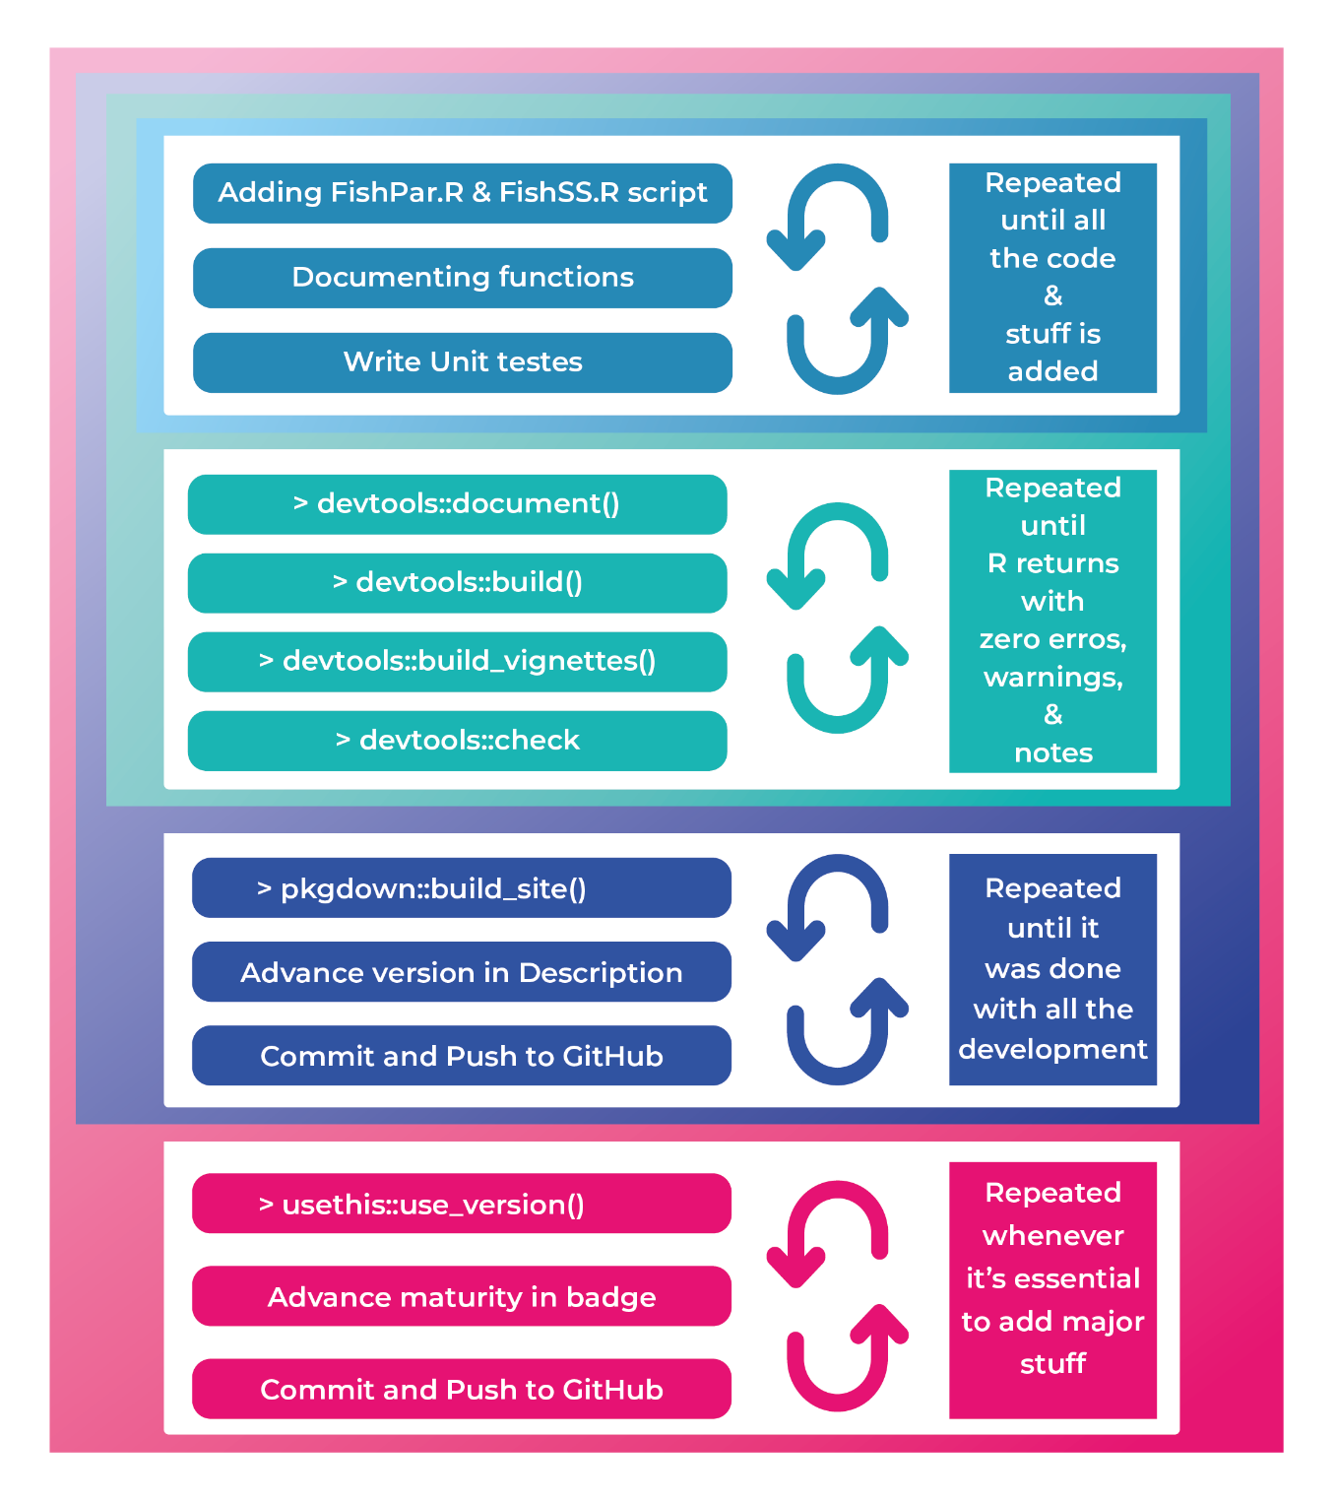Figure 4: Development and planning process of the functions of aLBI package
There are two R files containing two main functions named as FishPar and FishSS were (Figure 4) designed to estimate some of the key biological parameters (L_{max}, L∞, L_{mat}, L_{opt}, LM_ratio, Froese length indicators (P_{mat}, P_{opt}, P_{mega}), stock. The FishPar function processes length frequency data, performs bootstrap resampling to calculates key biological parameters, and generates corresponding plots (histograms and density plots, boxplot) for graphical visualization of the estimated parameters. On the contrary, FishSS function evaluates stock status (TSB40 and LSB25) based on length-based indicators (P_{obj}, P_{mat}, P_{opt}, LM_ration) by selecting specific columns and then values.
Table 1. Main Functions of aLBI R package
Functions | Descriptions | Usage | Arguments
FishPar | Calculates various length-based indicators for fish stock assessment using length frequency data and bootstrap resampling. | FishPar(data, resample, progress) | Data: A data frame containing two columns: Length and Frequency.  Resample: An integer indicating the number of bootstraps resamples.  Progress: A logical value indicating whether to display progress.
FishSS | Assesses the stock status based on parameters calculated by the FishPar function | FishSS(data, LM_ratio, P_{obj}, P_{mat}, P_{opt}) | Data: A data frame containing the necessary columns for stock status calculation. (Cope & Punt, 2009a)  LM_ratio: A numeric value representing the length at maturity ratio.  P_{obj}: A numeric value representing the percentage objective.  P_{mat}: A numeric value representing the percentage of mature fish.  P_{opt}: A numeric value representing the percentage of optimally sized fish.
The FishPar function facilitates this by estimating key biological parameters, such as the maximum length (L_{max}), asymptotic length (L∞), and length at maturity (L_{mat}), using bootstrap resampling techniques (Table 1). It ensures data integrity by validating input data and generating robust confidence intervals for parameter estimates. Additionally, it provides insightful visualizations to help interpret the results, making it a valuable tool for researchers and fishery managers. In addition, the FishSS function analyzes particular indicators such as LM_ratio and Pobj to ascertain the stock situation. Analyzing these indications helps one to choose suitable columns from the input data to create important stock metrics such Low Spawning Biomass (LSB25) and Total Spawning Bio mass (TSB40) (Table 2). This dual-function strategy improves our knowledge of fish population dynamics, therefore helping to guide the development of sensible management plans and fisheries policies. These purposes together promote the aim of sustainable fisheries management by incorporating statistical rigor with practical application.

Estimating growth parameters by FishPar function
The aLBI package estimate these parameters by the following formula:
L_{max} will be estimated from the length frequency data by FishPar function as followed:
$L_{max}=max⁡(data[1])$………….. (1)
Here, data[1] = first column of the length frequency data where length of the sampled data was recorded and pick up the largest length by max formula.
Then an initial value for L∞ was calculated using the following formula proposed by Pauly (1984):
$L_{∞}=\frac{L_{max}}{0.95}$……………. (2)
Here, L_{max} = previously calculated maximum length (L_{max})
To estimate the length at sexual maturity (L_{m}) an empirical equation proposed by Froese & Binohlan (2000) was used as followed:
$\log\left(L_{m}\right)=0.8979\left(\log\left(L_{∞}\right)\right)-0.0782$……………. (3)
Here, L∞ = previously calculated asymptotic length (L∞)

Estimating Length-Based Indicators (LBIs) by FishPar function
In order to evaluate the stock status in relation to exploitation and prevent excessive fishing that could harm development and recruitment, Froese (2004) suggested three straightforward length-based indicators (LBIs) known as P_{mat}, P_{opt}, and P_{mega}. These indicators are based on three fundamental principles.
- The first indication (P_{mat}) can be defined as the proportion of mature specimens in the catch, and it represents the concept of “let them spawn!” The objective is to ensure that every single fish (100%) is able to reproduce at least once before being caught, in order to restore and sustain a robust population of spawning fish. The percentage of fish in the capture that have a length larger than the length at sexual maturity (L_{m}) was determined using the following formula:
$P_{mat}=\sum_{L_{mat}}^{L_{max}}{P_{L}}$………………... (4)
- Indicator two (P_{opt}) can be defined as the percentage of fish caught at their optimal length, which is the length that maximizes the yield and revenue. It is determined by multiplying the number of fish in a specific year class that has not been fished with their average individual weight. The optimum length is generally somewhat bigger than the length at initial maturity and can be readily determined using growth and mortality parameters or empirical equations (Froese & Binohlan, 2000). The objective is to capture every fish (100%) within a range of around ±10% (between 0.9L_{opt} and 1.1L_{opt}) of the optimal length. It is calculated as follows:
$P_{opt}=\sum_{{0.9L}_{opt}}^{{1.1L}_{opt}}{P_{L}}$…………… (5)
- The Final one (P_{mega}) can be characterized as a strategy that involves allowing the entities to develop and allowing the mega-spawners to remain active. The metric is calculated as the proportion of mature fish in the catch that exceed the optimal length by 10% (1.1 times the optimal length). The purpose of the management regime is to execute a fishing technique that ensures no mega-spawners are caught, with a goal of 0% catch rate. In the absence of a specific strategy, the catch will mirror the age and size distribution of the stock. A range of 30-40% mega-spawners is indicative of a robust age structure and is considered favorable. However, if the proportion falls below 20%, it is a cause for concern. The calculation is determined using the following formula:
$P_{mega}=\sum_{{1.1L}_{opt}}^{L_{max}}{P_{L}}$…………… (6)
Where, P_{L} is the percentage of fish in the catch in the length interval L.

Package development and documentation
The development of the aLBI package is meticulously executed, adhering to established coding standards and best practices to ensure robustness and efficiency. Each function and module within the aLBI package is carefully crafted, tested, and optimized for performance. Comprehensive documentation is produced to accompany the development process (Figure 3), providing users with clear and detailed instructions on installation, configuration, and usages.
This documentation includes thorough descriptions of all functions, classes, and modules, accompanied by practical examples and use cases were automatically created with the roxygen2 (Wickham et al., 2024) packge. The package's comprehensive documentation includes a detailed README file, which offers an overview of the package, installation instructions, and a quick start guide. Vignettes are also provided, offering in-depth tutorials and real-world examples that showcase the package's capabilities. These vignettes are particularly useful for new users, as they provide step-by-step instructions on how to leverage the package for various analyses. Additionally, it details the dependencies and requirements needed for the package, ensuring users have all necessary information to integrate and utilize the package effectively. Regular updates and version control are maintained to keep the documentation current with any changes or improvements, ensuring users always have access to the latest features and fixes.

RESUTS

Installation of the package
Users of the aLBI package can install it in a simple and quick manner intended for minimum configuration and convenience of usage. The package is accessible on GitHub repository and also available on CRAN (https://cran.r-project.org/web/packages/aLBI/index.html). Users should first make sure R installed on their system corresponds with their preferred version 4.0.0 or above. For detailed installation instructions, troubleshooting tips, and additional information, users can refer to the vignettes (https://cran.r-project.org/web/packages/aLBI/vignettes/Introduction.html). This ensures a smooth installation process, allowing users to quickly integrate and utilize the aLBI package in their work.

Observed output of FishPar function
Length frequency data of Sperata aor was given input to the aLBI package for estimating the parameters and visualization of the plots for understanding the stock status.

Frequency distribution plot
The total lengths (TL) of 1177 Sperata aor individuals, ranging from 9.5 to 75 cm were measured. A frequency data frame with class intervals of 5 produced a unimodal length frequency distribution by aLBI package, The output reveals that the population is heavily skewed towards juveniles (Figure 5), with 783 individuals, indicating good recruitment but also potential growth overfishing. The mature fish count is relatively low at 145, suggesting many fish are not surviving to reach reproductive maturity. The optimum size category, with 167 fish, shows some fish are reaching a sustainable harvest size, while the low number of mega spawners at 82 (Table 2), this suggests that while juvenile and medium-sized fish are abundant, larger fish are relatively rare in the catch.
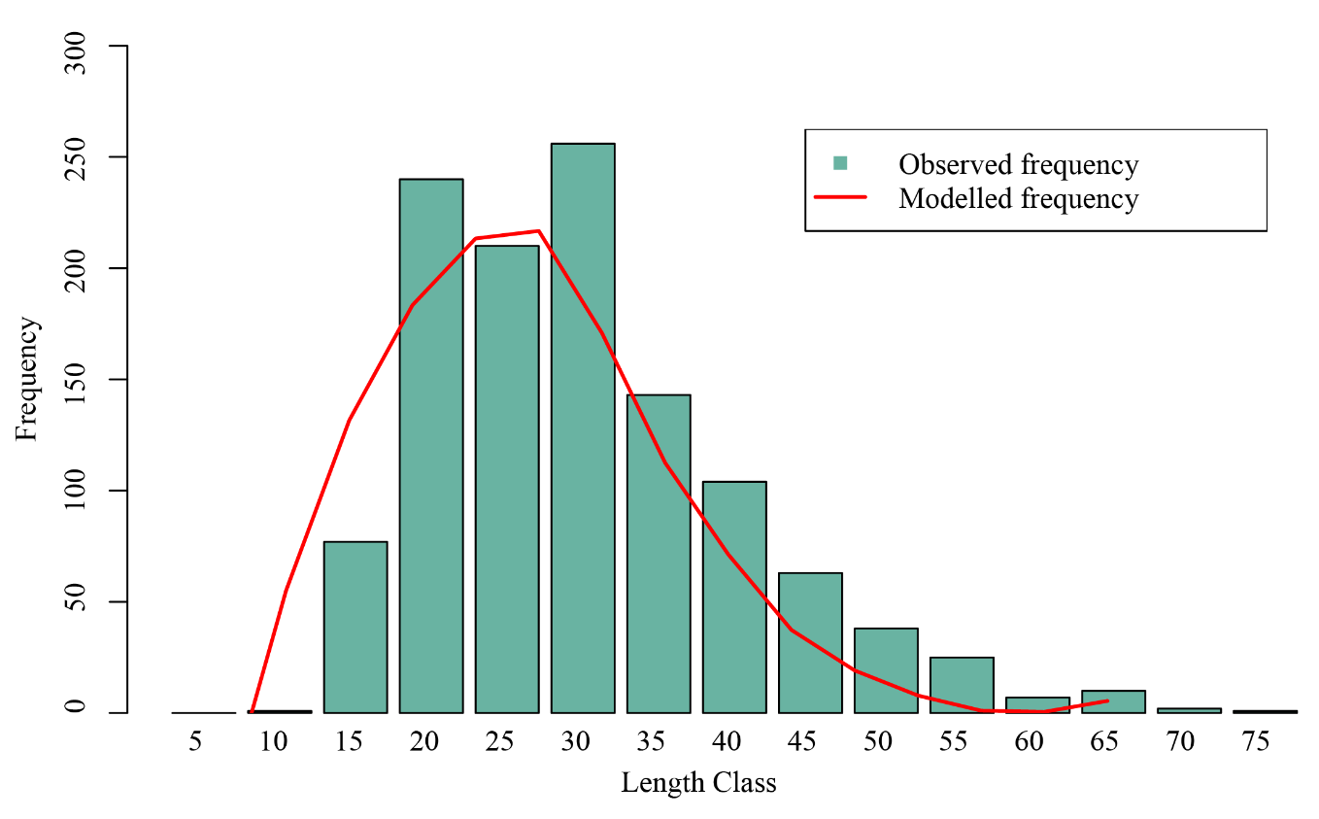
Figure 5: Plot showing the length frequency distribution of Sperata aor
The highest frequencies are observed at lengths of 30 cm (256 individuals) and followed by 20 cm (240 individuals), indicating these lengths are common among the fish population sampled. As the length increases beyond 30 cm, the frequency decreases significantly, with the lowest counts at the 5 cm, 10 cm, 65 cm, 70 cm, and 75 cm intervals (Figure 5).
Table 2. Estimated individuals of different length sizes of Sperata aor
Size category | Counts (n)
Juvenile/ Premature | 783
Mature | 145
Optimum size | 167
Mega spawner | 82
Total | 1177
L_{mat} = length at sexually maturity; L_{opt} = fish having length of L_{mat}±10%; Mega spawner = fish having length greater than L_{opt}+10%.

Estimating different length groups
The aLBI package produced a plot for different length groups of Sperata aor (Figure 6). The length-based metrics provided a comprehensive understanding of the fish stock status. Figure 6 depicts the mean maximum length (Lmax) of 72.43 cm and asymptotic length (L∞) of 76.24 cm suggest that fish can grow to substantial sizes if not overfished. The mean length at sexual maturity (L_{mat}) of 40.90 cm is crucial for maintaining reproductive capacity. The mean optimum length (L_{opt}) 43.72 (L_{mat}±10% = 39.35 to 48.09 cm) represents the ideal range which produces maximum biological yield (Table 4).
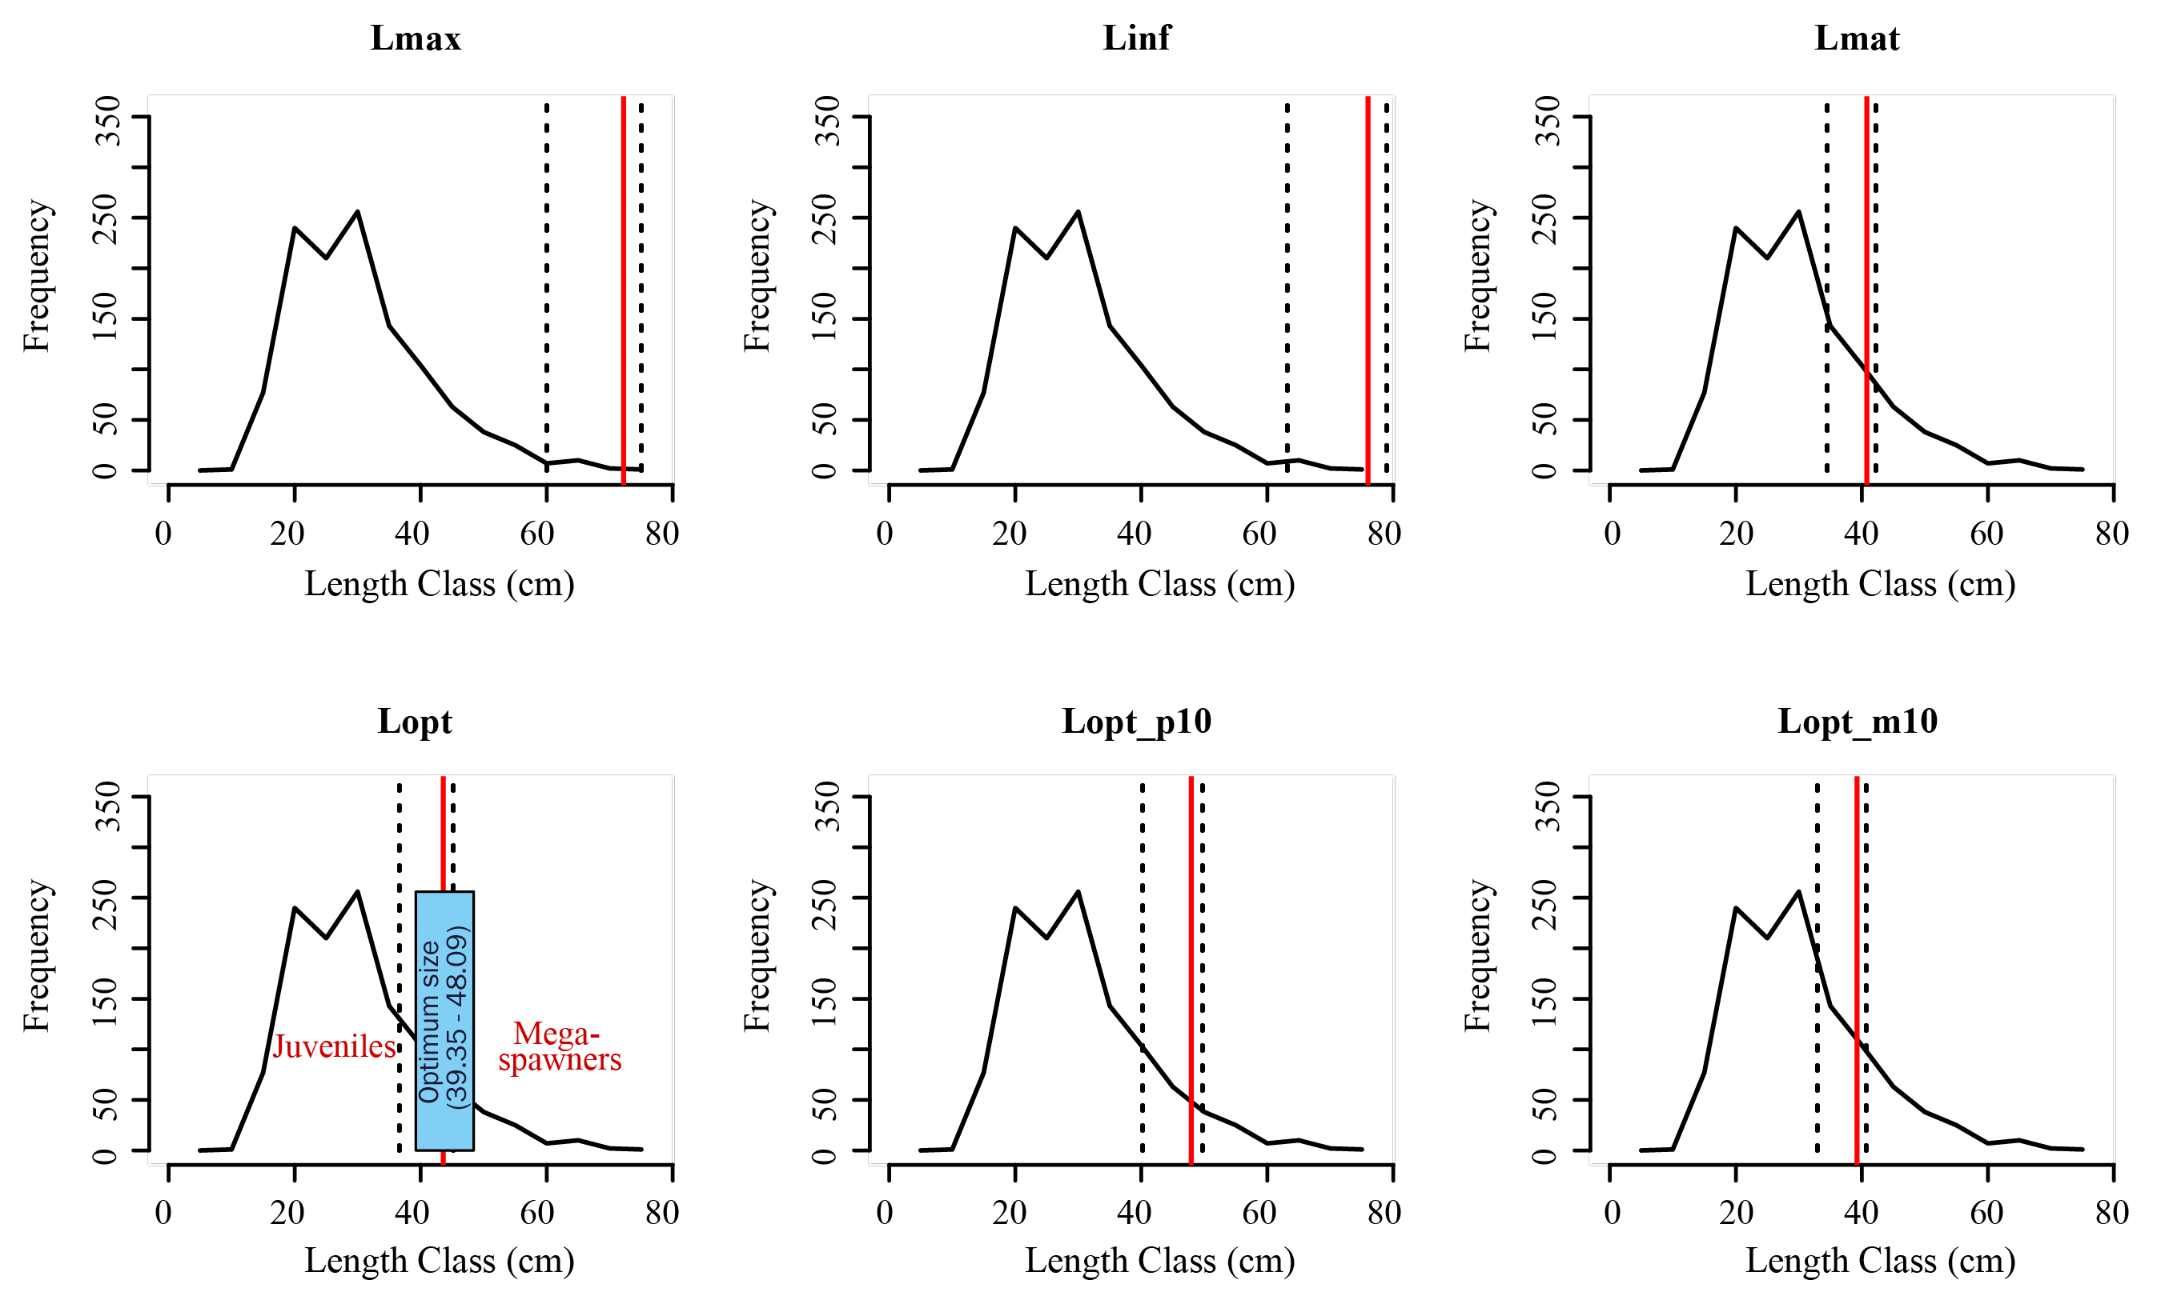
Figure 6: Plot showing the frequency line with different length size of Seperata aur. Solid red lines depict the mean estimates and dotted lines depicts the lower confidence interval (left) and upper confidence intervals (right).
The analysis of the length-based metrics using the aLB package reveals critical insights into the health and sustainability of the fish stock. Figure 7 illustrate the different length size of the Sperata aor. Output (parameters such as L_{max}, L∞, L_{mat}, and L_{opt}) driven from the aLBI package with mean estimates and confidence intervals provide a benchmark for assessing growth and maturity thresholds within the fish population.
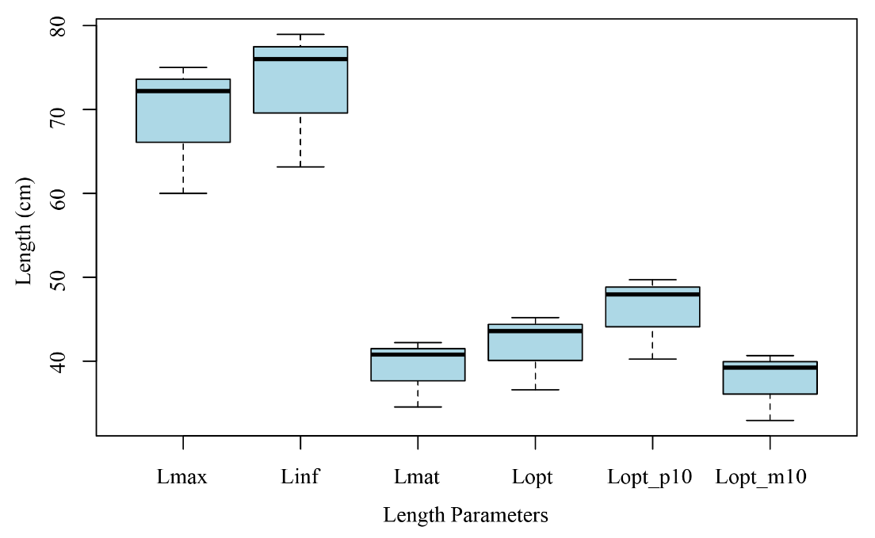
Figure 7: Boxplot showing the different lengths of Sperata aor
This visualization of aLBI package for different length parameters by boxplot (Figure 7) illustrate the distribution of various length parameters of the studied fish population. Each parameter is depicted with a boxplot showing the median, interquartile range (IQR), and confidence intervals (CI), providing insights into the central tendency and variability of these metrics.
These metrics highlight the need for size limits to protect juveniles and mature fish, continuous monitoring, and adaptive management to promote sustainable fishing practices and ensure the long-term health of the fish stock.

Length-Based Indicators (LBIs)
A simple set of indicators proposed by Froese (2004), LBIs (P_{mat}. P_{opt}, P_{mega}) was graphically visualized (Figure 8) by aLBI package as percentage (%) along with their respective target.
Table 3. Estimated length-based indicators (LBIs) by aLBI package
Parameters | Percentage (%) | Target (%)
P_{mat} | 12.319 | 100
P_{opt} | 14.189 | 100
P_{mega} | 6.967 | 20
P_{obj} | 33.475 | -
P_{mat} = percentage of sexually mature fish; P_{opt} = percentage of optimally length fish; P_{mega} = percentage of mega spawner; P_{obj} = sum of P_{mat}, P_{opt}, and P_{mega}
These are estimated based on the length at sexual maturity (Lmat) and used to assess the stock status of Sperata aor, fishery of Kaptai Lake. The expected values of catch-based length proportion are insufficient to support the specific reference target values proposed by Forese (2004). The percentage of wild fish in the catch was 12.13% (Table 3), suggesting that the population of mature fish is much below the intended level. This suggest that an approximately 88% of the fish are excluded from the stock already before being sexually mature, which is critical for maintaining the reproductive capacity and sustainability of the stock. Though fish in optimum range are ideal for sustainable harvesting because they have had the chance to reproduce at least once, the percentage of optimum size range is also much lower (14.189%) than the target which demonstrate the population is not being harvested sustainably, there is a risk of overfishing. Mega-spawners are crucial for maintaining genetic diversity and population resilience. In the absence of any size limit for the catch, relatively low percentage (only 6.967%) of larger fish (P_{mega} < 20%) could be interpreted as the significant proportion of the older or mega spawners are being heavily fished, which can undermine the long-term sustainability of the stock (Mora et al., 2009; Barneche et al., 2018).
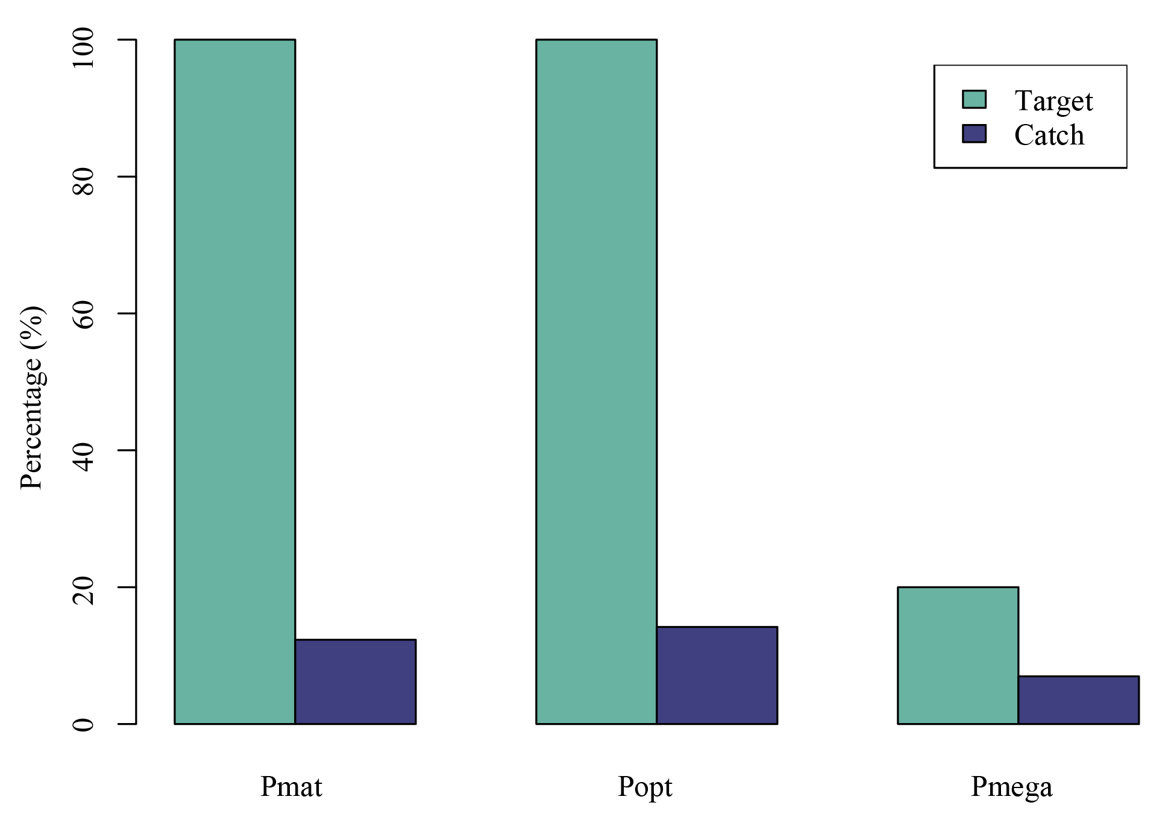
Figure 8: Plot showing the estimated length-based indicators of Sperata aor

Observed stock status of FishSS function
FishSS function facilitate the evaluation of stock status by quantifying the decision tree process. The sum of the all the three proportions (P_{mat}, P_{opt}, P_{mega}), termed as P_{obj}, provides comprehensive information to distinguish the selectivity patterns. However, the findings suggest that there is a 67% probability that the stock biomass below the target reference points or exceed both the target biomass level (TSB40) and the limit biomass level (LSB25). This suggests a relatively favorable status of the stock biomass, indicating a good likelihood of achieving and maintaining sustainable biomass levels.
Table 4. Estimated stock status of the Sperata aor by aLBI package
Stock status | Probability (%)
TSB40 | 67
LSB25 | 67
TSB40 = target biomass; LSB25 = limit biomass

DISCUSSION

Development and application of the aLBI package
Especially in data-limited conditions, the development of the aLBI package was motivated by the need of robust tools to evaluate fish stock situation using length-based indicators. Applying methods recommended by Cope & Punt (2009) and Froese (2004), the package generates a whole framework for computing significant parameters like L_{max}, L∞, L_{mat}, and L_{opt} as well as percentage indicators including P_{mat}, P_{opt}, and P_{mega}. These tools enable data-driven insights capable of guiding sustainable fisheries management. The ability of the program to visualize length frequency distributions and calculate confidence intervals helps managers and fisheries researchers more appreciate it (Hilborn et al., 2020; Froese, 2004). Many tests and validations were part of the development process to ensure reliability and correctness. User comments define usability and help to improve functioning. By allowing managers to use effective conservation measures and reach sustainable exploitation rates, the package helps decision-making by means of clear, pragmatic indicators (Cope & Punt, 2009). Its flexibility in practical fisheries management contexts is further reinforced by the mix of user-friendly interfaces and exhaustive documentation, hence promoting its acceptability over numerous fisheries and places (Punt et al., 2016).

Performance evaluation of aLBI package
The analysis revealed a significant proportion of the population as juvenile or premature individuals, comprising 66.5% of the total. This high percentage suggests a healthy recruitment rate, which is crucial for the sustainability of the stock. However, the relatively low percentages of mature (12.3%), optimum size (14.2%), and mega spawner (7.0%) individuals highlight potential challenges in achieving a balanced population structure. Management strategies should focus on ensuring these individuals can grow and contribute to the reproductive success of the population, ultimately enhancing stock resilience (Froese, 2004). These results align with earlier research showing that overfishing usually results in an overpopulation of young fish, which, under poor management, could cause recruitment overfishing (Beverton & Holt, 1957; Cushing, 1988). Furthermore, ensuring the genetic variety and long-term population health depends on keeping a balanced size distribution (Hixon et al., 2014).
Regarding length-based indicators, it was found that the percentages of mature individuals (P_{mat}), individuals at optimal size (P_{opt}), and mega spawners (P_{mega}) were somewhat low their respective targets. Particularly P_{mat} was 12.319% against a target of 100%, P_{opt} was 14.189% against a target of 100%, and P_{mega} was 6.967% against a target of 20%. These findings underline the need of management projects aimed to increase these rates. Including protected areas, seasonal closures, and size limitations helps one to meet these targets and ensure the long-term survival of the fish population (Froese, 2004; Hilborn et al., 2020). This is particularly important since the presence of mature and big spawner individuals preserving a healthy spawning biomass determines effective reproduction (Barrowman & Myers, 1996). The low percentages indicate possible overfishing pressure, thereby stressing the need of adaptive management strategies able to react to changing stock conditions (Hilborn, 2007).
However, the stock status probabilities for TSB40 (67%) and LSB25 (67%) are promising, indicating a moderately high likelihood that the stock biomass will meet or exceed both the target and limit levels. These probabilities suggest that while there are challenges, the stock is not in immediate danger. Continuous monitoring and adaptive management are essential to maintain and improve these probabilities, ensuring the resilience of the stock (Cope & Punt, 2009). The use of probability-based stock status indicators is a valuable approach in data-limited fisheries, as it provides a measure of uncertainty and helps in making precautionary management decisions (Punt et al., 2016). Moreover, maintaining stock biomass above critical thresholds is crucial for avoiding recruitment overfishing and ensuring the long-term productivity of the fishery (Mace & Sissenwine, 1993).

Recommendation’s for Management
The results of the aLBI package underline the need of ongoing observation and flexible management plans. Although the decreased percentages of mature, ideal size, and mega spawner individuals highlight the need of protective measures, the great number of young/premature individuals shows future possibility for development. Management techniques aiming at improving stock sustainability should concentrate on:
a. Preserving young and preterm individuals as they develop into adults by means of policies aiming at their survival. This can include size restrictions meant to stop young fish from being harvested and safeguard their growth capacity (Froese, 2004). Preserving young people guarantees that more people will reach reproductive age, so helping to replenish the supply (Barrowman & Myers, 1996).
b. Improving Growth to Optimum Size: Control of harvest quantities will enable fish to reach their ideal size before capture. This approach guarantees that people have the chance to participate to the reproductive pool, therefore fostering population resilience and stability (Hilborn et al., 2020). Furthermore, maximizing the economic worth of the catch is optimal size harvesting since larger fish usually command higher market prices (Froese et al., 2012).
c. Establishing no-take zones or seasonal closures will help to safeguard mega spawners and hence preserve most reproductively valuable individuals. Mega spawners mostly help the population to be more successful in reproduction; so, their protection is absolutely essential for maintaining stock biomass (Cope & Punt, 2009). Long-term resilience depends on the genetic variety and flexibility of the population; hence protection of mega spawners helps preserve these features as well (Hixon et al., 2014).
These approaches will help fisheries managers to guarantee that both ecological and financial goals are satisfied by encouraging a good and sustainable fish population. Applying the aLBI package emphasizes the need of using length-based indicators in data-limited fisheries, therefore enabling a thorough study supporting strong, data-driven management decisions (Hilborn et al., 2020).

CONCLUSION
Length-based indicators and life history parameters, the aLBI package has shown its role in evaluating fish stock situation. The examination of the given data exposed a notable percentage of young and preterm fish, so suggesting a good rate of recruitment. The low percentages of mature, ideal size, and mega spawner individuals, however, emphasize the need of targeted management techniques to guarantee these fish can grow and help the population to be reproductively successful. Important benchmarks for sustainable management techniques are given by the biometric metrics L_{max}, L∞, L_{mat}, and L_{opt}. Encouraging stock status probabilities for TSB40 and LSB25 indicate that, respectively, the stock biomass is probably either likely to meet or exceed target and limit values. All things considered, the aLBI package provides strong instruments for fishery managers to make wise, fact-based decisions bolstering the sustainable use of fish resources.
Particularly in data-limited situations, the necessity of strong tools to evaluate fish stock situation using length-based indicators drove the development of the aLBI package. Using approaches suggested by Cope and Punt (2009) and Froese (2004), the package implements a complete framework for approximating important parameters including L_{max}, L∞, L_{mat}, and L_{opt} as well as percentage indicators including P_{mat}, P_{opt}, and P_{mega}. These instruments help to provide data-driven insights that might direct sustainable fisheries management. For managers and fisheries researchers, the package's capacity to visualize length frequency distributions and compute confidence intervals increases its value.

Limitations of the study
Notwithstanding its advantages, the development and application of the aLBI package was limited in some respects. Data collecting proved challenging especially in severe weather, which regularly caused delays and partial data sets. This constraint highlights the need of robust and flexible data collecting methods adapted to environmental uncertainty. Moreover, the development of the aLBI package required meticulous testing and validation to ensure dependability and correctness. Technical constraints and limited resources often hampered the development process, which stresses the importance of continuous investment in software development and user feedback mechanisms.

Author Contributions

A.A.: conceptualization, methodology, data collection, data analysis, visualization, and writing, M.R.S.: writing, reviewing and editing, M.S.A.: conceptualization, methodology, data analysis, writing, reviewing, editing, and supervision. All authors have read and agreed to the published version of the manuscript.

Ethics Statement

The authors have nothing to report.

Conflicts of Interest

The authors declare no conflicts of interest.

Data Availability Statement

Data will be available on request to corresponding author.
Funding
The authors received no specific funding for this research.

REFERENCES
Ault, J. S., Smith, S. G., Bohnsack, J. A., Luo, J., Stevens, M. H., DiNardo, G. T., Johnson, M. W., & Bryan, D. R. (2019). Length-based risk analysis for assessing sustainability of data-limited tropical reef fisheries. ICES Journal of Marine Science, 76(1), 165–180. https://doi.org/10.1093/icesjms/fsy123
Barneche, D. R., Robertson, D. R., White, C. R., & Marshall, D. J. (2018). Fish reproductive-energy output increases disproportionately with body size. Science, 360(6389), 642–645. https://doi.org/10.1126/science.aao6868
Barrowman, N. J., & Myers, R. A. (1996). Is fish recruitment related to spawner abundance. Fishery Bulletin, 94, 707-724.
Beverton, R. J. H., & Holt, S. J. (1957). On the dynamics of exploited fish populations. Fisheries Investigations Series II, Volume 19, 533 pages. HMSO, London.
Canales, C. M., Hurtado, C., & Techeira, C. (2018). Implementing a model for data-poor fisheries based on steepness of the stock-recruitment relationship, natural mortality and local perception of population depletion. The case of the kelp Lessonia berteroana on coasts of north-central Chile. Fisheries Research, 198, 31–42. https://doi.org/10.1016/j.fishres.2017.10.017
Chong, L., Mildenberger, T. K., Rudd, M. B., Taylor, M. H., Cope, J. M., Branch, T. A., Wolff, M., & Stäbler, M. (2020). Performance evaluation of data-limited, length-based stock assessment methods. ICES Journal of Marine Science, 77(1), 97–108. https://doi.org/10.1093/icesjms/fsz212
Cope, J. M., & Punt, A. E. (2009). Length‐Based Reference Points for Data‐Limited Situations: Applications and Restrictions. Marine and Coastal Fisheries, 1(1), 169–186. https://doi.org/10.1577/C08-025.1
FAO. (2020). The state of world fisheries and aquaculture 2020. Food and Agriculture Organization of the United Nations.
Free, C. M., Jensen, O. P., Wiedenmann, J., & Deroba, J. J. (2017). The refined ORCS approach: A catch-based method for estimating stock status and catch limits for data-poor fish stocks. Fisheries Research, 193, 60–70. https://doi.org/10.1016/j.fishres.2017.03.017
Froese, R. (2004). Keep it simple: Three indicators to deal with overfishing. Fish and Fisheries, 5(1), 86–91. https://doi.org/10.1111/j.1467-2979.2004.00144.x
Froese, R., & Binohlan, C. (2000). Empirical relationships to estimate asymptotic length, length at first maturity and length at maximum yield per recruit in fishes, with a simple method to evaluate length frequency data. Journal of Fish Biology, 56(4), 758–773. https://doi.org/10.1111/j.1095-8649.2000.tb00870.x
Froese, R., Winker, H., Coro, G., Demirel, N., Tsikliras, A. C., Dimarchopoulou, D., Scarcella, G., Probst, W. N., Dureuil, M., & Pauly, D. (2018). A new approach for estimating stock status from length frequency data. ICES Journal of Marine Science, 75(6), 2004–2015. https://doi.org/10.1093/icesjms/fsy078
Gayanilo, F. C., Sparre, P., & Pauly, D. (2005). FAO-ICLARM stock assessment tools II (FiSAT II). Revised version. User's guide. FAO Computerized Information Series (Fisheries), No. 8.
Gelman, A., & Shalizi, C. R. (2013). Philosophy and the practice of Bayesian statistics. British Journal of Mathematical and Statistical Psychology, 66(1), 8–38. https://doi.org/10.1111/j.2044-8317.2011.02037.x
Hilborn, R. (2007). Managing fisheries is managing people: What has been learned? Fish and Fisheries, 8(4), 285–296. https://doi.org/10.1111/j.1467-2979.2007.00263_2.x
Hilborn, R., & Walters, C. J. (1992). Role of Stock Assessment in Fisheries Management. In R. Hilborn & C. J. Walters (Eds.), Quantitative Fisheries Stock Assessment: Choice, Dynamics and Uncertainty (pp. 3–21). Springer US. https://doi.org/10.1007/978-1-4615-3598-0_1
Hilborn, R., Amoroso, R. O., Anderson, C. M., Baum, J. K., Branch, T. A., Costello, C., de Moor, C. L., Faraj, A., Hively, D., Jensen, O. P., Kurota, H., Little, L. R., Mace, P., McClanahan, T., Melnychuk, M. C., Minto, C., Osio, G. C., Parma, A. M., Pons, M., … Ye, Y. (2020). Effective fisheries management instrumental in improving fish stock status. Proceedings of the National Academy of Sciences, 117(4), 2218–2224. https://doi.org/10.1073/pnas.1909726116
Hixon, M. A., Johnson, D. W., & Sogard, S. M. (2014). BOFFFFs: On the importance of conserving old-growth age structure in fishery populations. ICES Journal of Marine Science, 71(8), 2171–2185. https://doi.org/10.1093/icesjms/fst200
Hoggarth, D. D., Abeyasekera, S., Arthur, R., Beddington, J. R., Burn, R. W., Halls, A. S., ... & Welcomme, R. L. (2006). Stock assessment for fishery management: A framework guide to the stock assessment tools of the Fisheries Management Science Programme (FMSP) (FAO Fisheries Technical Paper No. 487).
Hordyk, A. R., Loneragan, N. R., & Prince, J. D. (2015). An evaluation of an iterative harvest strategy for data-poor fisheries using the length-based spawning potential ratio assessment methodology. Fisheries Research, 171, 20–32. https://doi.org/10.1016/j.fishres.2014.12.018
Hossain, M. Y., Rahman, Md. M., Fulanda, B., Jewel, M. a. S., Ahamed, F., & Ohtomi, J. (2012). Length–weight and length–length relationships of five threatened fish species from the Jamuna (Brahmaputra River tributary) River, northern Bangladesh. Journal of Applied Ichthyology, 28(2), 275–277. https://doi.org/10.1111/j.1439-0426.2011.01900.x
Khatun, M. H., Zahangir, M. M., Akhter, B., Parvej, M. R., & Liu, Q. (2023). Clupeids in the kaptai reservoir, a blessing or a curse: Estimation of fisheries reference points. Heliyon, 9(3). https://doi.org/10.1016/j.heliyon.2023.e13818
Mace, P. M., & Sissenwine, M. P. (1993). How much spawning per recruit is enough? Canadian Special Publication of Fisheries and Aquatic Sciences, 120, 101-118.
Martell, S., & Froese, R. (2013). A simple method for estimating MSY from catch and resilience. Fish and Fisheries, 14(4), 504–514. https://doi.org/10.1111/j.1467-2979.2012.00485.x
Mildenberger, T. K., Taylor, M. H., & Wolff, M. (2017). "TropFishR: An R package for fisheries analysis with length-frequency data." Methods in Ecology and Evolution, 8(11), 1520-1527.
Mora, C., Myers, R. A., Coll, M., Libralato, S., Pitcher, T. J., Sumaila, R. U., Zeller, D., Watson, R., Gaston, K. J., & Worm, B. (2009). Management Effectiveness of the World’s Marine Fisheries. PLOS Biology, 7(6), e1000131. https://doi.org/10.1371/journal.pbio.1000131
Nelson, G. A. (2017). fishmethods: Fishery Science Methods and Models (1.12-1) [Computer software]. https://cran.r-project.org/web/packages/fishmethods/index.html
Olden, J. D., Lawler, J. J., & Poff, N. L. (2008). Machine Learning Methods Without Tears: A Primer for Ecologists. The Quarterly Review of Biology, 83(2), 171–193. https://doi.org/10.1086/587826
Pauly, D. (1984). Fish Population Dynamics in Tropical Waters: A Manual for Use with Programmable Calculators. WorldFish.
Pauly, D., & Morgan, G. R. (Eds.). (1987). Length-based methods in fisheries research (Vol. 13). WorldFish.
Pilling, G. M., Kell, L. T., Hutton, T., Bromley, P. J., Tidd, A. N., & Bolle, L. J. (2008). Can economic and biological management objectives be achieved by the use of MSY-based reference points? A North Sea plaice (Pleuronectes platessa) and sole (Solea solea) case study. ICES Journal of Marine Science, 65(6), 1069–1080. https://doi.org/10.1093/icesjms/fsn063
Pilling, G. M., Kell, L. T., Hutton, T., Bromley, P. J., Tidd, A. N., & Bolle, L. J. (2008). Can economic and biological management objectives be achieved by the use of MSY-based reference points? A North Sea plaice (Pleuronectes platessa) and sole (Solea solea) case study. ICES Journal of Marine Science, 65(6), 1069–1080. https://doi.org/10.1093/icesjms/fsn063
Prince, J., Victor, S., Kloulchad, V., & Hordyk, A. (2015). Length based SPR assessment of eleven Indo-Pacific coral reef fish populations in Palau. Fisheries Research, 171, 42–58. https://doi.org/10.1016/j.fishres.2015.06.008
Punt, A. E., Butterworth, D. S., de Moor, C. L., De Oliveira, J. A. A., & Haddon, M. (2016). Management strategy evaluation: Best practices. Fish and Fisheries, 17(2), 303–334. https://doi.org/10.1111/faf.12104
Punt, A. E., Dunn, A., Elvarsson, B. Þ., Hampton, J., Hoyle, S. D., Maunder, M. N., Methot, R. D., & Nielsen, A. (2020). Essential features of the next-generation integrated fisheries stock assessment package: A perspective. Fisheries Research, 229, 105617. https://doi.org/10.1016/j.fishres.2020.105617
Punt, A. E., Tuck, G. N., Day, J., Canales, C. M., Cope, J. M., de Moor, C. L., De Oliveira, J. A. A., Dickey-Collas, M., Elvarsson, B. Þ., Haltuch, M. A., Hamel, O. S., Hicks, A. C., Legault, C. M., Lynch, P. D., & Wilberg, M. J. (2020). When are model-based stock assessments rejected for use in management and what happens then? Fisheries Research, 224, 105465. https://doi.org/10.1016/j.fishres.2019.105465
Rana, S., Hasan, Md. N., Bari, A. A., Shimul, S. A., Ahmed, Sk. I., & Nahid, Sk. A. A. (2024). Problems and prospects of fish farming in the Chattogram Hill Tracts of Bangladesh: Community-based aquaculture might be a right choice. Aquaculture and Fisheries, 9(2), 306–313. https://doi.org/10.1016/j.aaf.2022.04.002
Rudd, M. B., & Thorson, J. T. (2018). Accounting for variable recruitment and fishing mortality in length-based stock assessments for data-limited fisheries. Canadian Journal of Fisheries and Aquatic Sciences, 75(7), 1019–1035. https://doi.org/10.1139/cjfas-2017-0143
Scott, F., Jardim, E., Millar, C. P., & Cerviño, S. (2016). An Applied Framework for Incorporating Multiple Sources of Uncertainty in Fisheries Stock Assessments. PLOS ONE, 11(5), e0154922. https://doi.org/10.1371/journal.pone.0154922
Shalehin, Md. S., Parvez, Md. T., Lucas, M. C., & Galib, S. M. (2022). A case study of illegal fishing causes during seasonal fishery closure in Kaptai Lake, Bangladesh. Fisheries Management and Ecology, 29(5), 542–551. https://doi.org/10.1111/fme.12536
Sparre, P., & Venema, S. C. (1998). Introduction to tropical fish stock assessment. Part 1: Manual. FAO Fisheries Technical Paper No. 306.1, Rev. 2. FAO.
Thorson, J. T., & Cope, J. M. (2015). Catch curve stock-reduction analysis: An alternative solution to the catch equations. Fisheries Research, 171, 33–41. https://doi.org/10.1016/j.fishres.2014.03.024
Thorson, J. T., Jensen, O. P., & Zipkin, E. F. (2014). How variable is recruitment for exploited marine fishes? A hierarchical model for testing life history theory. Canadian Journal of Fisheries and Aquatic Sciences, 71(7), 973–983. https://doi.org/10.1139/cjfas-2013-0645
Wickham, H. (2015). R Package. O'Reilly Media, Inc. ISBN: 9781491910542. https://www.oreilly.com/library/view/r-packages/9781491910580/
Wickham, H., Danenberg, P., Csárdi, G., Eugster, M., Software, P., & PBC. (2024). roxygen2: In-Line Documentation for R (7.3.2) [Computer software]. https://cran.r-project.org/web/packages/roxygen2/index.html
Zhou, S., Punt, A. E., Ye, Y., Ellis, N., Dichmont, C. M., Haddon, M., Smith, D. C., & Smith, A. D. (2017). Estimating stock depletion level from patterns of catch history. Fish and Fisheries, 18(4), 742–751. https://doi.org/10.1111/faf.12201

